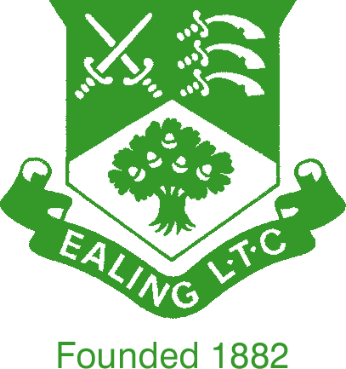 | BANK HOLIDAY  MIXED DOUBLES TOURNAMENT

Monday 29 August

Entrance fee: £5 per person payable on the day (cash or card).

The format for this fun tournament will be pairs placed in groups, as near as possible to their standard. Each group will play round robin matches using a sliding handicap. The winners of each group will play off against the winners of other groups to determine the finalists.

Every effort will be made to find partners where necessary.

To enter: Sign up in the clubhouse or send me an email.

Email entries by Sunday 28 August, in pairs if possible (or partner required). Those not signed up should be at the club by at 11.00am to allow sufficient time for the draw to be written up, for play to start at 12.00 noon.

Janis Dodd has kindly offered to provide sandwiches for lunch for a small charge, payable by cash only.

Janice Coulthard
07803 922 246
janice.coulthard@ntlworld.com

